**Semester Tests**

**Question 1**

**2015**

1. Differentiate between the different components of an Information Systems Development Methodology.

* The philosophical approach on which it is based;
* The process model that should be followed;
* The method itself; and
* The tools and techniques to be used.

2014

1. Define an Information System Development Methodology

* A collection of procedures, techniques, tools and documentation aids which will help the system developers in their efforts to implement a new IS. A methodology will consist of phases, themselves consisting of sub-system, which will guide the systems developers in their choice of the techniques.

**2013**

1. What are the weaknesses of the System Development Life Cycle (SDLC)?

* Failure to meet the needs of management
* Instability
* Inflexibility
* User dissatisfaction
* Problems with documentation
* Lack of Control
* Incomplete system

**2012**

1. Describe the human influence on ISD

* Programmers – code and develop a system in a computer language.
* System analysts – specify the requirements for a system and the outline designs and solutions that will meet the requirements.
* Business analysts – understand the complexities of the business and its need and liaise with the system analyst
* Project managers – manage the project with particular emphasis on schedules and resources.

**Question 2**

**2015**

1. Draw up a table showing the differences and similarities between STRADIS and Information Engineering

|  |  |
| --- | --- |
| **STRADIS** | **Information Engineering (IE)** |
| Initial Study | Information strategy planning |
| Detailed study | Business area analysis |
| Defining and designing alternative solutions | System design |
| Physical design | Construction and cutover |

**2014**

1. Discuss the four of the six phases in the ISDLC

* **Feasibility study** : looks at legally, Organisationally and socially, Technically and Economically
* **Systems Investigation**: Looks at the functional requirements of the existing system (if there is one) and whether these requirements are being achieved
* **Systems Analysis**: attempt to understand all aspects of the present system and why it was developed as it did
* **Systems Analysis**: this stage involves the design of both the computer and manual parts of the system
* **Implementation**: focuses on Code and test programs, purchase hardware and software and quality control
* **Review and maintenance**: this process happens once the system is operational

**2013**

1. Name and discuss three process oriented methodologies.

STRADIS: Structured design is concerned with the selection and organisation of modules and interfaces that would save a pre-defined problem: STRADIS consist of four stages namely:

* Initial study
* Detailed study
* Defining and designing alternative solutions
* Physical design

Yourdon System Method (YSM): YSM uses an approach called event partitioning and it consist of 3 phases namely:

* Feasibility study
* Construction essential model
* Construction implementation model

Jackson System Development (JSD): The primary purpose of JSD is to produce maintainable software, and its emphasis is on developing software systems. JSD consist of 3 phases:

* Modelling phase
* Network phase
* Implementation phase

**2012**

Same as 2014

**Question 3**

**2015**

1. What are the benefits of the object-oriented approach?

* Object-oriented concepts unify many aspects of the information system development process
* It facilitates the realistic reuse of software code and therefore makes application development quicker and more robust
* It integrates methods of systems development with the systems context

**2014**

1. What is most important aspect of the STRADIS methodology?

* The important aspect of the STARDIS methodology is the bringing together of many of the techniques. These techniques utilizes as a form used by many different methodology.

**2013**

1. Discuss the steps in Information Engineering (IE) design?

* **Preliminary data structure design**: this step is performed at the level of the whole business and not just the design area
* **System structure design**: this step involves the mapping business processes to procedures, and the interactions
* **Procedure design**: this step involve the development of data navigation diagrams, dialogues flows and the drawing of action diagrams
* **Confirmation**: this stage is to confirm completeness, correctness and usability
* **Planning for technical design**: this stage involve the definition of implementation areas and the preparations of technical design plan

**2012**

1. Same as 2014

**Question 4**

**2015**

1. Discuss the different phases Extreme Programming (XP) methodology

* **Planning:** relates to the scope of the project, the priority of the functions and the members of the team
* **Designing:** is done on the principles of simplicity, feedback and courage, and enabling incremental change
* **Developing:** the code includes the principles of paired programming, testing using programmer and user data
* **Productionalising:** may also be seen as part of developing, but the tests at this time ensure fitness for production of the whole system

**2014**

1. What is normalization? Discuss the three basic stages of Normalization

* Normalization: the process that helps to minimize data redundancy
* **1NF**: ensures that all the attributes are atomic
* **2NF**: ensures that all non-key attributes are functionally dependent on all the key
* **3NF**: ensures that all non-key attributes are functionally independent to each other

**2013**

1. Discuss the four phases of the RUP methodology

* **Inception:** This is where the project business case is stated and the team decides if the project is worth doing
* **Elaboration:** This where the developers take a closer look at the project determine its architecture foundation
* **Construction:** This is where the development of the project is completed
* **Transition:** This is where any fine-tuning is performed

**2012**

1. Describe the different techniques of data modelling in an organisation

* To assist business analysts, programmers, testers, manual writers, IT package selectors, engineers, managers, related organizations and clients to understand and use an agreed semi-formal model the concepts of the organization and how they relate to one another
* To manage data as a resource
* For the integration of information systems
* For designing databases/data warehouses (aka data repositories)

**Question 5**

**2015**

1. Discuss the qualities to improve the human-computer interface

* Visibility: This has two aspects. First, it means that the way the system works is seen by users. Secondly providing information on the current activities through messages to the users
* Simplicity: This means that the presentation of information to the users should be well structured
* Consistency: This means that the human-computer interface follows a similar pattern through the system
* Flexibility: This means that the users can adapt the interface to suit their own requirements

**2014**

1. Discuss with the help of a diagram the RUP process structure

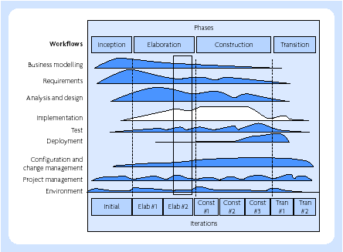

* RUP has a number of cycles and run throughout its life cycle, viz.
* Inception
* Elaboration
* Construction; and
* Transition
* A workflow is a sequence of activities that produce a result of observable value and there are nine core processes workflows in RUP.
* The three support workflow i.e. configuration and change management, project management and environment
* The first six workflows are called engineering workflows

**2013**

3. Calculate the people-months required for 3400 instructions.

PM = 2.4(KDSI) 1.05

PM = 2.4(3400) 1.05

**2012**

Same as **2013**

**Question 6**

**2015**

1. Draw a “Rich Picture” of a professional association

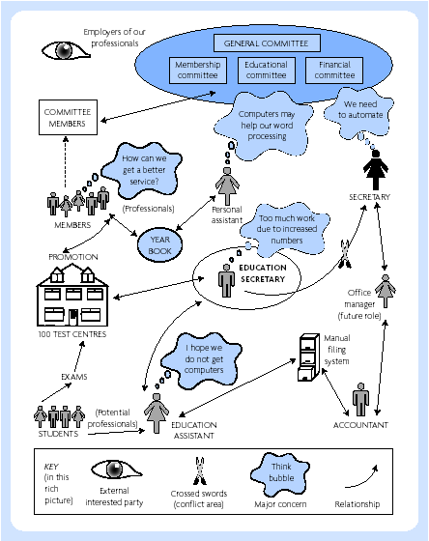

**2014**

1. Discuss MoSCoW rules

* M = ‘the Must Haves’. Without these features the project is not available.
* S = ‘the Should Haves’. To gain maximum benefit these features will be delivered but the project’s success does not rely on them.
* C = ‘the Could Haves’. If time and resources allow these features will be delivered but they can easily be left out without impacting on the project.
* W = ‘the Won’t Haves’. These features will not be delivered. They can be left out and possibly, although not necessarily, be done in a later timebox.

**2013**

1. Same as **2014**

**2012**

1. What are the characteristics of a project where prototyping is particularly beneficial?

* Unclear requirements
* Unstable requirements
* High innovativeness
* High system impact on the organization
* High system impact on users
* Relatively small project size

**Question 7**

**2015**

1. Discuss the Capability Maturity Model (CMM) framework in terms of the five maturity levels.

* **Initial:** at this level processes are generally not defined, and success or failure depends on the capabilities of the individuals involved
* **Repeatable:** policies for managing software development are identified and established based on experience
* **Defined:** at this level, the standard software engineering and management processes are documented and form a coherent
* **Managed:** at this level quantitative quality and productivity measures are established for key software development activities across all projects
* **Optimising:** at level 5 the whole organization is focused on continuous process improvement on a proactive basis

**2014**

1. Discuss the typical characteristics of JAD workshop

* **An intensive meeting of business users and IS people:** There should be specific objectives and a structured agenda, including rules of behaviour and protocols
* **A defined length of meeting:** This is typically one or two days, but can be up to five
* **A structured meeting room:** The layout of the room is regarded as important in helping to achieve the meeting objectives
* **A facilitator:** This is a person who leads and manage the meeting
* **A scribe:** This is a person responsible for documenting the discussions and outcomes of the meeting

**2013**

1. Discuss the Effective technical and human implementation of computer based system (ETHICS) methodology in terms of die components of a system development methodology

* Philosophical approach: Human orientated and social technical
* Process Model: Steps that are completed in cycles
* Techniques: Role player analysis and JAD (Joint application)

**2012**

1. Same as **2013**

**Question 8**

**2015**

1. In evaluating an application package what questions should be asked to ensure that the right package is purchase for organisations?

* Does it meet functional requirements?
* - What resources are required to buy and run these packages?
* - How many people are presently using the package?
* - What is the quality of the documentation?

**2014**

1. Discuss with the help of a diagram the stages of growth of an organisation

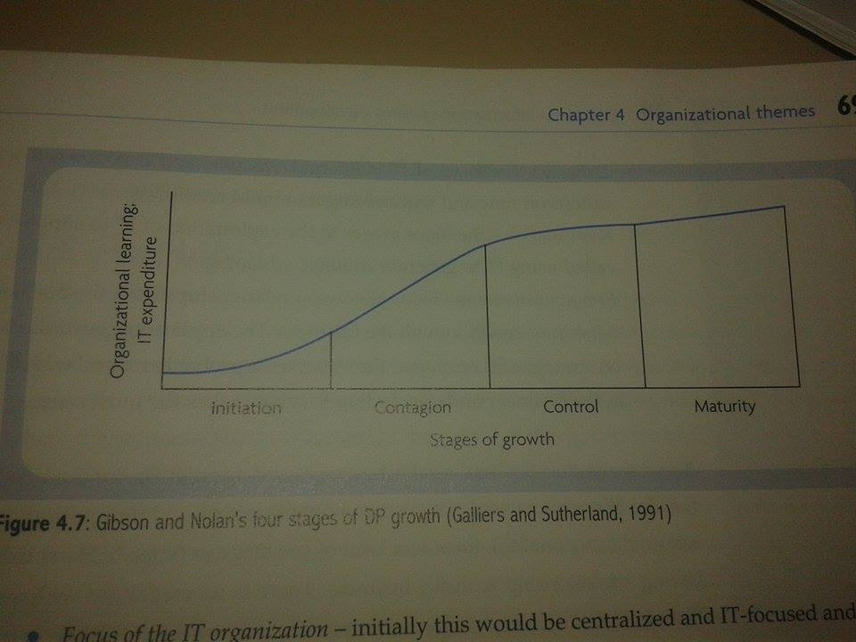

* Scope of the application portfolio: typically an organization would start its IT development by implementing mainly financial and accounting applications.
* Focus of the IT organization: initially this would be centralized and IT-focused and move to decentralized and data resource-focused in maturity
* Focus of IT planning and control: initially this would be an internal focus through to a more external focus in maturity
* Level of user awareness: this concerns the sources of the IT initiatives in the organization

**Exams**

**Question 1**

**2014**

1. Discuss the components of a SDM

* The philosophical approach on which it is based;
* The process model that should be followed;
* The method itself; and
* The tools and techniques to be used.
  1. Alternative methodology assumptions:
* A system which makes most use of computer is a good system
* A system which produce the most appropriate documentation is a good solution
* A system which is the cheapest to run is a good solution
* A system which is implemented earliest is a good system
* A system which makes is the most adaptable is a good solution
  1. Alternative methodology objects
* To record accurately the requirements for an IS
* To provide a systematic method of development
* To provide an IS within an appropriate time limit and at an acceptable cost
* To provide a system which is well documented and easy to maintain
  1. Techniques: a way of doing a particular activity in the ISD process.
  2. Tools: each technique may involve the use of one or more tools that represents some of the artefacts used in ISD

**Question 1**

**2013**

1. Discuss the need for an ISD

* There was a growing appreciation of that part of the development of the system that concerns analysis and design and therefore of the role of the systems analyst as well as that of the programmer.
* There was a realisation that as organisations were growing in size and complexity, it was desirable to move away from one-off solutions to a particular problem and towards a more integrated information system.
* There was an appreciation of the desirability of an accepted methodology for the development of information systems.

**Question1**

**2012**

1. Discuss an IS

* A system which assembles, stores, processes and delivers information relevant to an organisation (or to society), in such a way that the information is accessible and useful to those who wish to use it, including managers, staff, clients and citizens. An information system is a human activity (social) system which may or may not involve the use of computer systems